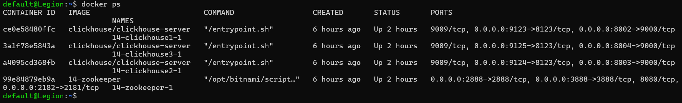

**DROP** **TABLE** **IF** **EXISTS** default.trips;

**CREATE** **TABLE** default.trips

(

**`trip_id`** **UInt32**,

**`pickup_datetime`** **DateTime**,

**`dropoff_datetime`** **DateTime**,

**`pickup_longitude`** Nullable(**Float64**),

**`pickup_latitude`** Nullable(**Float64**),

**`dropoff_longitude`** Nullable(**Float64**),

**`dropoff_latitude`** Nullable(**Float64**),

**`passenger_count`** **UInt8**,

**`trip_distance`** **Float32**,

**`fare_amount`** **Float32**,

**`extra`** **Float32**,

**`tip_amount`** **Float32**,

**`tolls_amount`** **Float32**,

**`total_amount`** **Float32**,

**`payment_type`** **Enum8**('CSH' = 1,

'CRE' = 2,

'NOC' = 3,

'DIS' = 4,

'UNK' = 5),

**`pickup_ntaname`** LowCardinality(**String**),

**`dropoff_ntaname`** LowCardinality(**String**)

)

**ENGINE** = MergeTree

**ORDER** **BY** (pickup_datetime, dropoff_datetime);

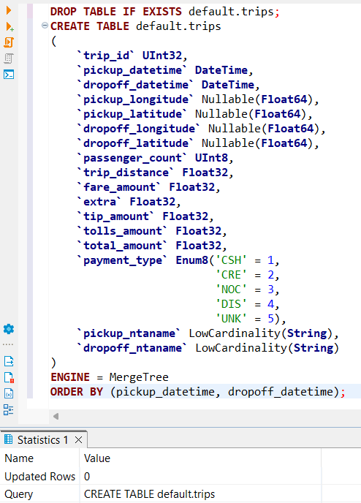

**create** **table** trips_replic **as** trips **ENGINE**=ReplicatedMergeTree('/clickhouse/{database}/{table}', '{replica}')

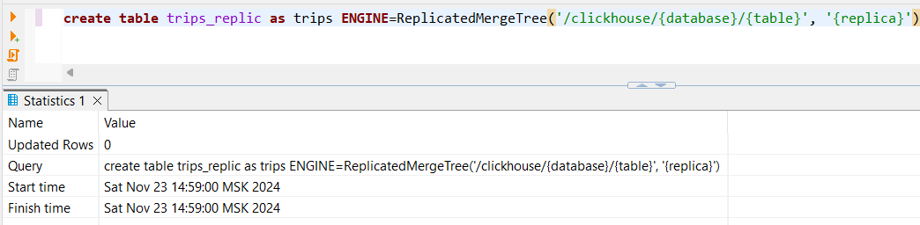

**INSERT** **INTO** trips_replic

**SELECT**

trip_id,

pickup_datetime,

dropoff_datetime,

pickup_longitude,

pickup_latitude,

dropoff_longitude,

dropoff_latitude,

passenger_count,

trip_distance,

fare_amount,

extra,

tip_amount,

tolls_amount,

total_amount,

payment_type,

pickup_ntaname,

dropoff_ntaname

**FROM**

gcs(

'https://storage.googleapis.com/clickhouse-public-datasets/nyc-taxi/trips_{0..2}.gz',

'TabSeparatedWithNames'

);

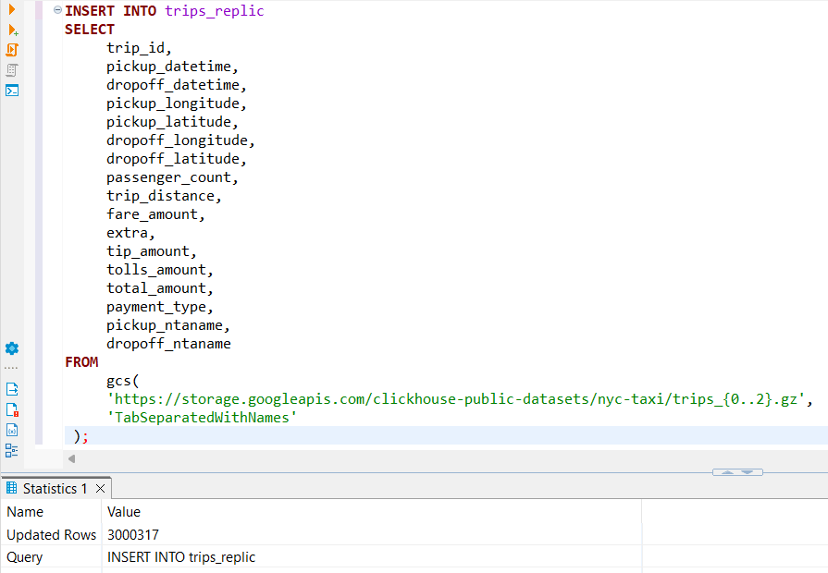

**SELECT**

**getMacro**('replica'),

*

**FROM**

remote('clickhouse1,clickhouse2,clickhouse3', 'default', 'trips_replic', 'default', 'default')

**FORMAT** JSONEachRow;

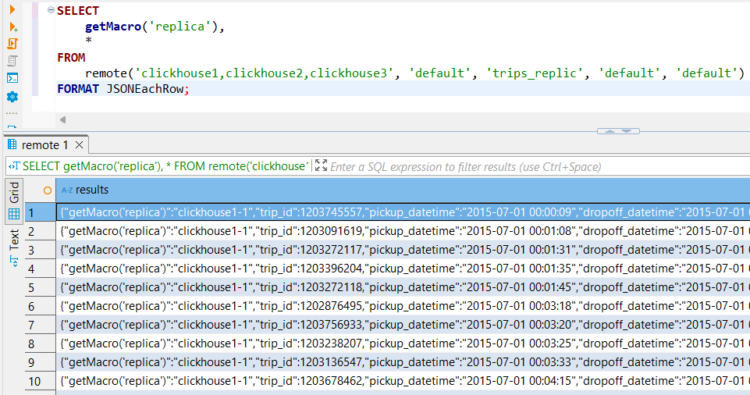

**SELECT** **distinct**

**getMacro**('replica')

**FROM**

remote('clickhouse1,clickhouse2,clickhouse3',

'default',

'trips_replic',

'default',

'default')

**FORMAT** JSONEachRow;

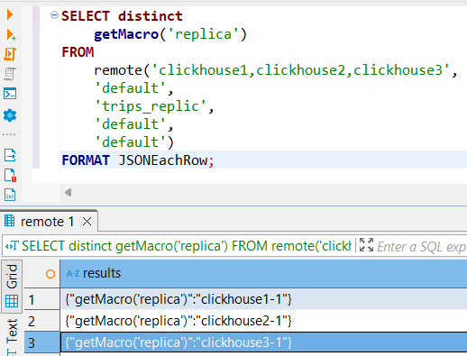

**SELECT** * **FROM** system.replicas **FORMAT** JSONEachRow;

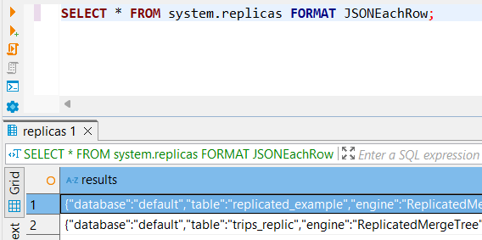

|{"database":"default","table":"replicated_example","engine":"ReplicatedMergeTree","is_leader":1,"can_become_leader":1,"is_readonly":0,"readonly_start_time":null,"is_session_expired":0,"future_parts":0,"parts_to_check":0,"zookeeper_name":"default","zookeeper_path":" clickhouse default replicated_example","replica_name":"clickhouse1-1","replica_path":" clickhouse default replicated_example replicas clickhouse1-1","columns_version":-1,"queue_size":0,"inserts_in_queue":0,"merges_in_queue":0,"part_mutations_in_queue":0,"queue_oldest_time":"1970-01-01 00:00:00","inserts_oldest_time":"1970-01-01 00:00:00","merges_oldest_time":"1970-01-01 00:00:00","part_mutations_oldest_time":"1970-01-01 00:00:00","oldest_part_to_get":"","oldest_part_to_merge_to":"","oldest_part_to_mutate_to":"","log_max_index":"0","log_pointer":"1","last_queue_update":"2024-11-23 10:55:59","absolute_delay":"0","total_replicas":3,"active_replicas":3,"lost_part_count":"0","last_queue_update_exception":"","zookeeper_exception":"","replica_is_active":{"clickhouse1-1":1,"clickhouse2-1":1,"clickhouse3-1":1}}|

|{"database":"default","table":"trips_replic","engine":"ReplicatedMergeTree","is_leader":1,"can_become_leader":1,"is_readonly":0,"readonly_start_time":null,"is_session_expired":0,"future_parts":0,"parts_to_check":0,"zookeeper_name":"default","zookeeper_path":" clickhouse default trips_replic","replica_name":"clickhouse1-1","replica_path":" clickhouse default trips_replic replicas clickhouse1-1","columns_version":-1,"queue_size":0,"inserts_in_queue":0,"merges_in_queue":0,"part_mutations_in_queue":0,"queue_oldest_time":"1970-01-01 00:00:00","inserts_oldest_time":"1970-01-01 00:00:00","merges_oldest_time":"1970-01-01 00:00:00","part_mutations_oldest_time":"1970-01-01 00:00:00","oldest_part_to_get":"","oldest_part_to_merge_to":"","oldest_part_to_mutate_to":"","log_max_index":"2","log_pointer":"3","last_queue_update":"2024-11-23 12:11:39","absolute_delay":"0","total_replicas":3,"active_replicas":3,"lost_part_count":"0","last_queue_update_exception":"","zookeeper_exception":"","replica_is_active":{"clickhouse1-1":1,"clickhouse2-1":1,"clickhouse3-1":1}}

**ALTER** **TABLE** default.trips_replic

**MODIFY** TTL pickup_datetime + **INTERVAL** 7 **DAY**;

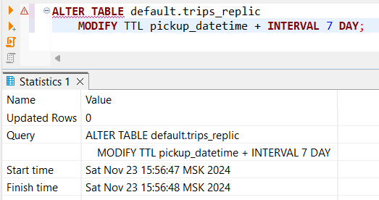

**SHOW** **CREATE** **TABLE** default.trips_replic;

